Dis-Eur-Spain-Huelva-Plaque-Biomorph Whiskered

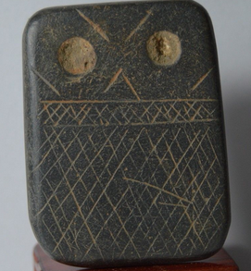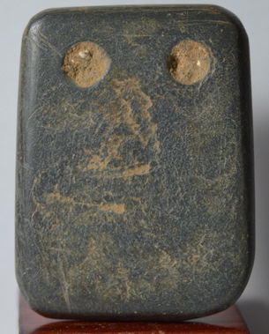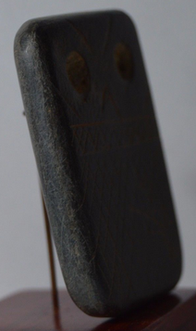

**Formal Label:** Late Neolithic slate plaque ca. 3,500–2,750 BCE) Badajoz, Spain

**Accession Number:**

**Date or Time Horizon:** **3500-2750 BCE**

**Geographical Area:** SW Spain

**Cultural Affiliation:** Late Neolithic

**Medium:** Slate

**Dimensions:**

**Weight:**

**Provenance:**

**Condition: Excellent**

**Discussion:**

This Late Neolithic engraved slate plaque ca. 3,500–2,750 BCE (calibrated age) from La Pijotilla2, Badajoz, Spain (southwest Iberian Peninsula) has three registers: a lower register of six levels of cross-hatcheurs, a middle register of two cross-hatcheurs set off by horizontal lines and an upper register of “eye” designs with a drilled hole through which strings were passed (based on use-wear analysis) so that it was worn as an amulet. While each of the six to ten “styles” of these slate plaques is distinctive in its specific details, each style exhibits a consistency in basic form, structure, and grammar.

The emergence of craft specialization in Late Neolithic Iberia reflects a shift in growing cultural stability in which various tribal groups began to coalesce around identities of social expression. These identities are reflected in the expressions of grammars of design incorporated into these engraved slates. The social shift underlying these design grammars represents articulation of social identities of several groups to a coalescence of these groups into cultural nodes reflective of fewer identities (Clark and Blake 2004; Flad and Hruby 2007; Helms 1993; Sennett 2008).

REFERENCES

Bibliography of Iberian Plaque Studies

Åberg, N. (1921). Civilisation énéolithique dans la péninsule ibérique. Uppsala, A.-b. Akademiska bokhandeln i kommission.

Almagro Gorbea, M. J. (1973). Los Idolos del Bronce I Hispano. Madrid, Consejo Superior de Investigaciones Científicas.

Ameghino, F. (1879). "L'homme préhistorique dans La Plata." Revue d'Anthropologie **2**: 210-249.

Breuil, H. (1935). Les peintures rupestres schématiques de la Penínsule Ibérique. Paris.

Bueno Ramírez, P. (1992). "Les plaques décorées alentéjaines: approche de leur étude et analyse." L’Anthropologie **96**(2-3): 573-604.

Carpenter, E., Ed. (1986-1988.). Materials for the study of social symbolism in ancient & tribal art : a record of tradition & continuity/ based on the researches & writings of Carl Schuster. New York, Rock Foundation.

Cartailhac, E. (1886). Les ages préhistoriques de l'Espagne et du Portugal. Paris, Ch. Reinwald.

Correia, V. (1917). "Arte pré-histórico: os idolos-placas." Terra Portuguesa **12**: 29-35.

Correia, V. (1921). El Neolítico de Pavía. Madrid, Museo Nacional de Ciencias Naturales.

Frankowski, E. (1920). Estelas Discoideas de la Península Ibérica. Madrid, Museo Nacional de Ciencias Naturales.

Gimbutas, M. (1991). Civilization of the Goddess : The World of Old Europe. San Francisco, HarperSanFrancisco.

Gonçalves, V. S. (1999). Reguengos de Monsaraz: Territórios Megalíticos. Lisbon, Câmara Municipal de Reguengos de Monsaraz.

Leisner, G., and Vera Leisner (1943). Die Megalithgräber der Iberischen Halbinsel. Der Süden. Berlin, Walter de Gruyter.

Leisner, G., and Vera Leisner (1951). Antas do Concelho de Reguengos de Monsaraz. Lisbon, Uniarch.

Leisner, G., and Vera Leisner (1956). Die Megalithgräber der Iberischen Halbinsel. Der Westen. Berlin, Walter de Gruyter.

Leisner, G., and Vera Leisner (1959). Die Megalithgräber der Iberischen Halbinsel. Der Westen. Berlin, Walter de Gruyter.

Leisner, V. (1965). Die Megalithgräber der Iberischen Halbinsel. Der Westen. Berlin, Walter de Gruyter.

Leisner, V. (1998). Die Megalithgraber der Iberischen Halbinsel: Der Westen. Madrider Forschungen Vol. I, 4. Berlin, Walter de Gruyter.

Lillios, K. T. (2002). "Some new views of the engraved slate plaques of southwest Iberia." Revista Portuguesa de Arqueologia **5**(2): 135-151.

Lillios, K. T. (2003). Creating memory in prehistory: the engraved slate plaques of southwest Iberia. Archaeologies of Memory. R. van Dyke and S. Alcock. Oxford, Blackwell**:** 129-150.

Lisboa, I. M. G. (1985). "Meaning and messages: mapping style in the Iberian Chalcolithic." Cambridge Archaeological Review **4**(2): 181-196.

Morgan, J. d. (1897). Récherches sur les origines de l'Égypte. Paris, E. Leroux.

Mortillet, G. de, and Adrien de Mortillet (1881). Musée préhistorique. Paris, C. Reinwald.

Pinto, A. M. and J. S. Pinto (1978). Problemas de análise descritiva de placas de xisto gravadas do megalitismo português. 1a Mesa-Redonda Sobre o Neolítico e o Calcolítico em Portugal, Porto.

Ribeiro, C. (1878-1880). Estudos prehistoricos em Portugal; noticia de algumas estações e monumentos prehistoricos, memoria apresentada á Academia real das sciencias de Lisboa. Lisbon, Typ. da Academia.

Rodrigues, M. da C. M. (1986). Código Para a Análise das Placas de Xisto Gravadas do Alto Alentejo. Castelo de Vide, Câmara Municipal de Castelo de Vide.

Rodrigues, M. da C. M. (1986). Estudo Ideológico-Simbólico das Placas de Xisto Gravadas. Castelo de Vide, Câmara Municipal de Castelo de Vide.

Simões, A. F. (1878). Introducção a archeologia da Peninsula Iberica. Lisbon, Livraria Ferreira.

Siret, H., and Louis Siret (1887). Les premiers âges du métal dans le sud-est de l'Espagne. Anvers.

Siret, L. (1913). Questions de chronologie et d'ethnographie ibériques. Paris, Paul Geuthner.

Vasconcellos, J. L. de and Sociedade de Geografia de Lisboa. (1897). Religiões da Lusitania na parte que principalmente se refere a Portugal. Lisboa, Imprensa Nacional.

Vasconcellos, J. L. de (1906). "Portugalia." O Arqueólogo Portugês **11**: 321-379.

Veiga, S. P. M. E. da (1887). Antiguidades monumentaes do Algarve: tempos prehistoricos. Lisboa, Imprensa nacional.

SLATE PLAQUE CHALCOLITHIC ANTHROPOMORPHIC IDOL.

Southwest Iberian Bronze Age type. Similar published in the:"Iberian Antiquities from the collection of Leon Levy & Shelby White", Figure 4, page 30.

Size: 4,8 x 3,7 centimeters.

Dated: Twenty to Fifteen Century Before Christ.

Condition: Excellent, calcareum adhesions cleaned in the anverse.

Provenance: Belgian Collection acquired 1980´s.